Assignment Date | 19 September
Student Roll No | 1901261
Student Name | Visveswar Srinivasan S
Marks | 2

1.Pull an Image from docker hub and run it in docker playground.

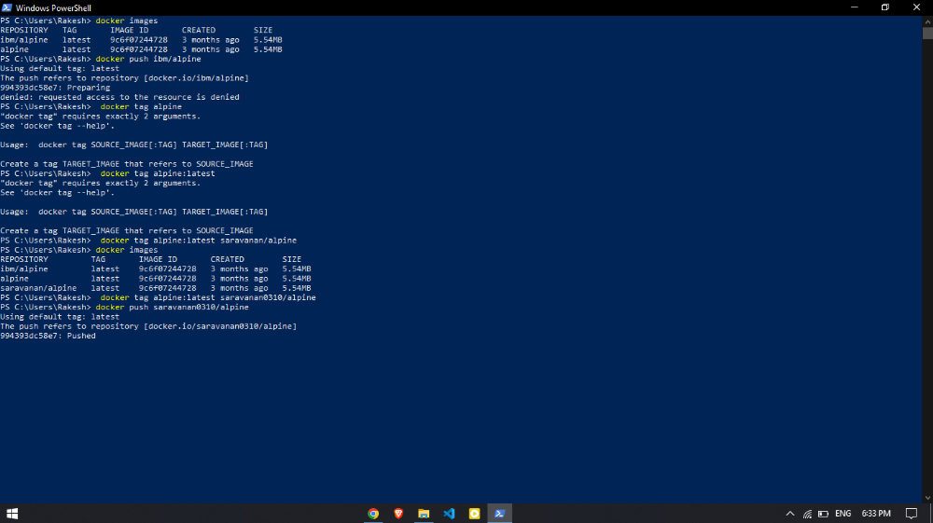

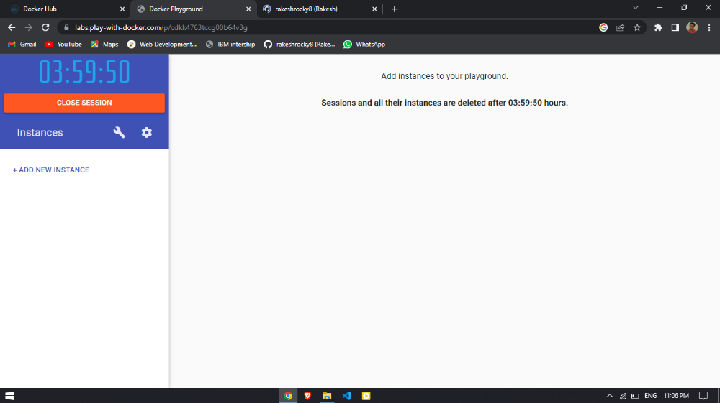

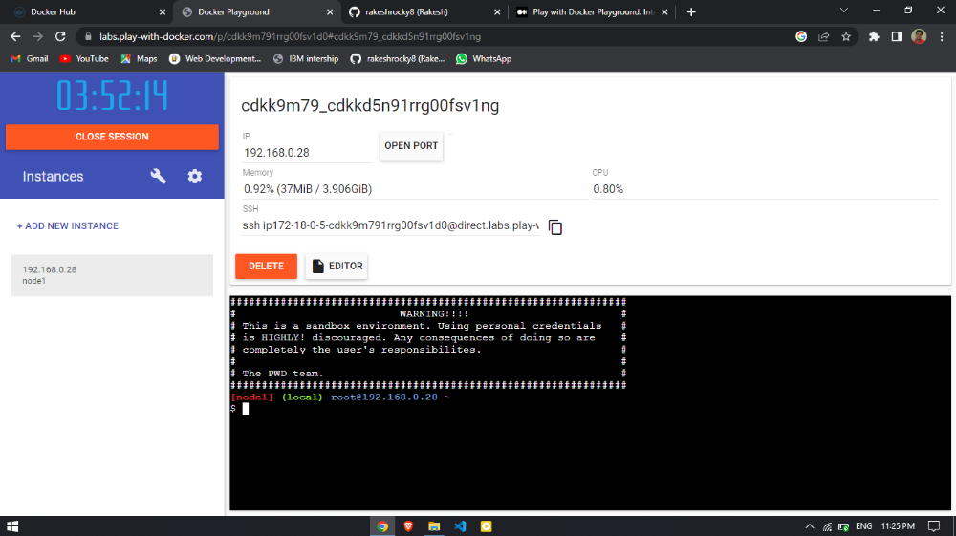

2.Create a docker file for the jobportal application and deploy it in Docker desktop application

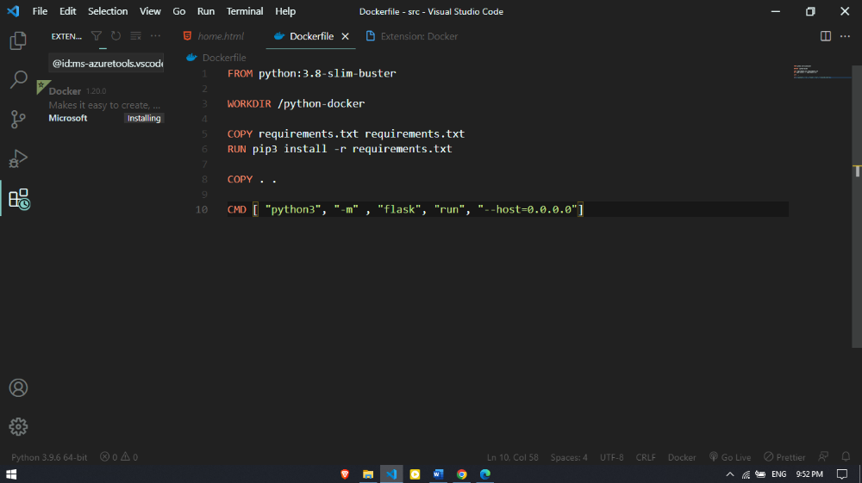

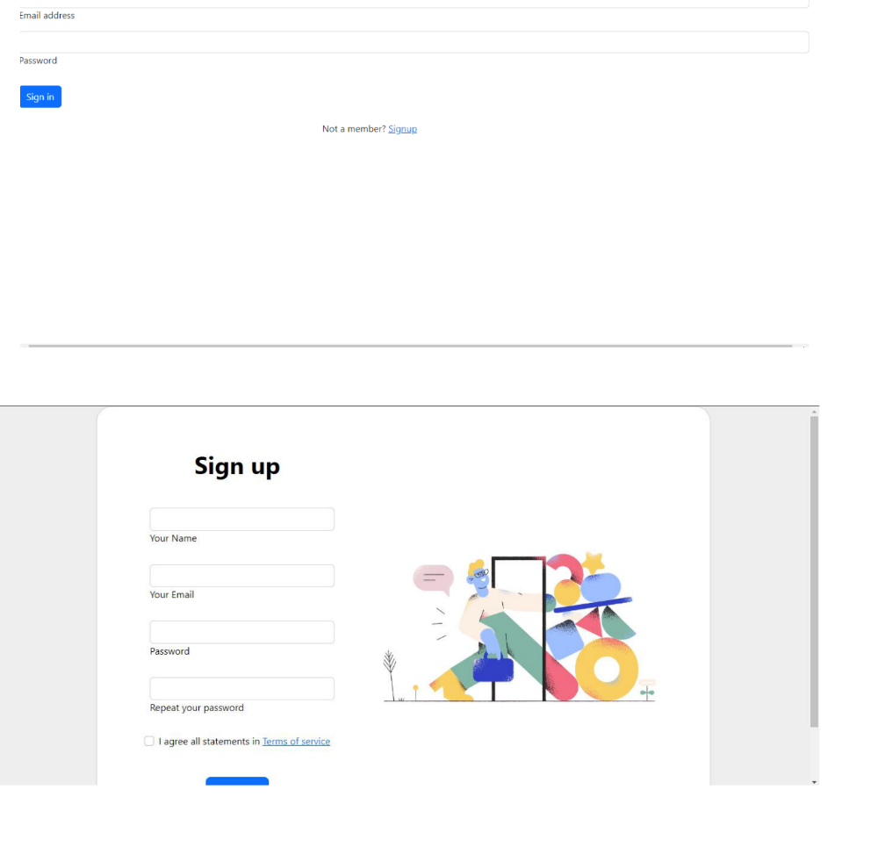
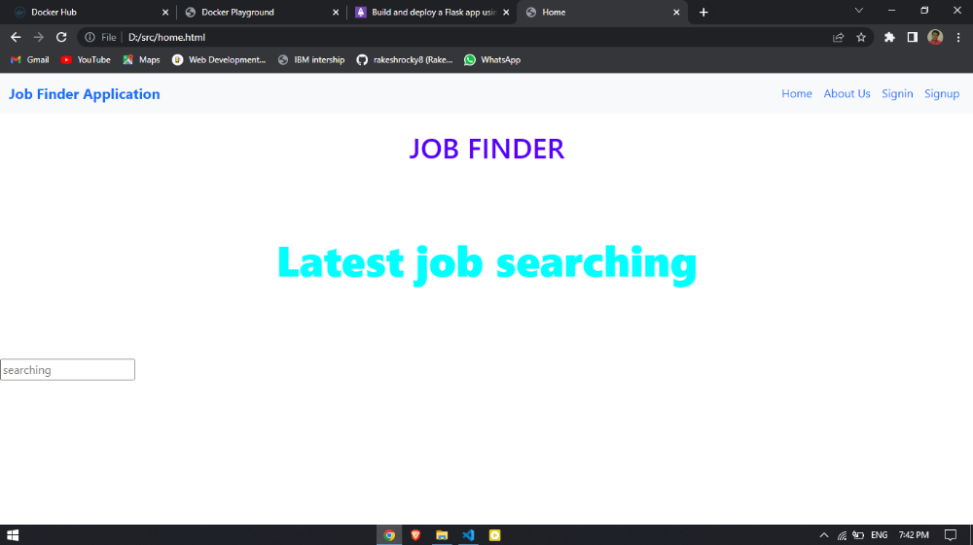

3.Create a IBM container registry and deploy helloworld app or jobportalapp

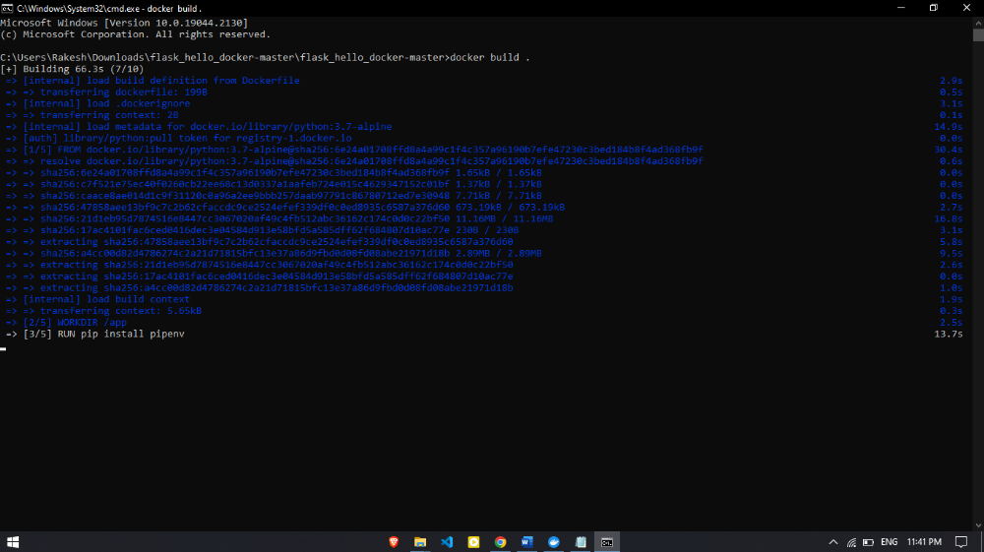

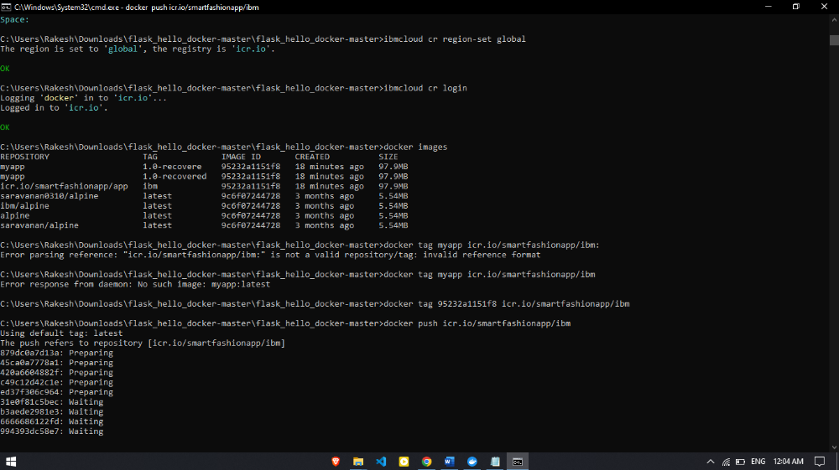

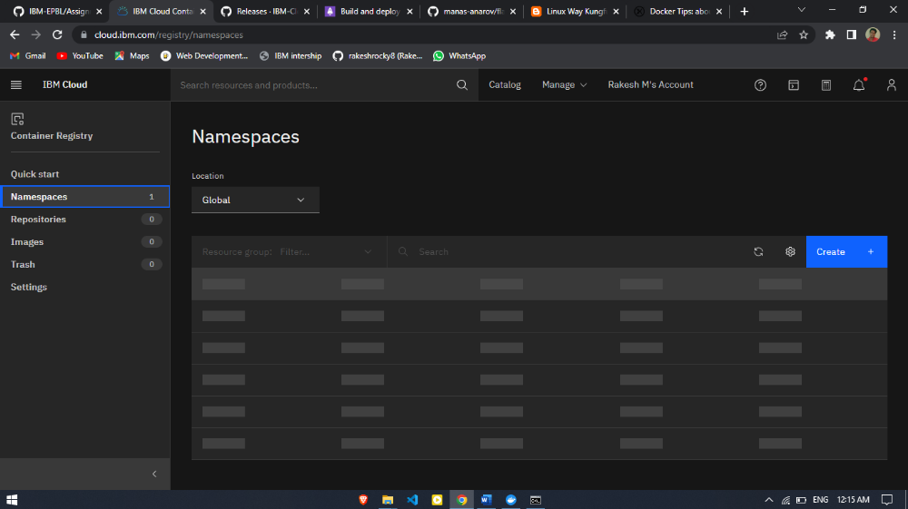

4.Create a Kubernetes cluster in IBM cloud and deploy helloworld image or jobportal image and also expose the same app to run in nodeport.

